**Set 1**

* Count total no. of Employees
* Count total no. of employees in HR dept
* Count total no. of employees in each dept
* Count total no. of employees earning 9000 or below in each dept
* Count distinct joining months in the employee table
* Find the employee with the lowest salary
* Find the lowest salaries in each dept
* Find month-wise minimum salaries
* Find full employee detail having the lowest salary
* Find the employee with the highest salary
* Find the highest salaries in each dept
* Find month-wise maximum salaries
* Find full employee detail having the 3rd highest salary
* Find the sum all employee salaries
* Find the sum of salaries in each dept
* Find month-wise sum of salaries
* Find the AVG of all employee salaries
* Find the AVG of salaries in each dept
* Find month-wise AVG of salaries

**Set 2**

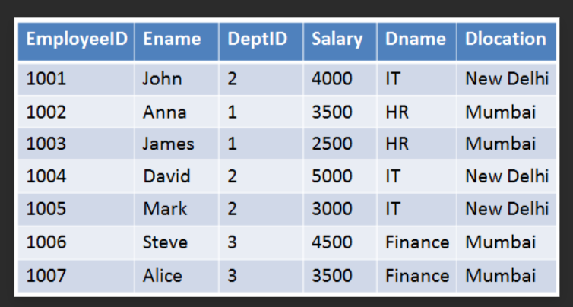

* Sort the Above table by Salary and Partition by Department

**Set 3**

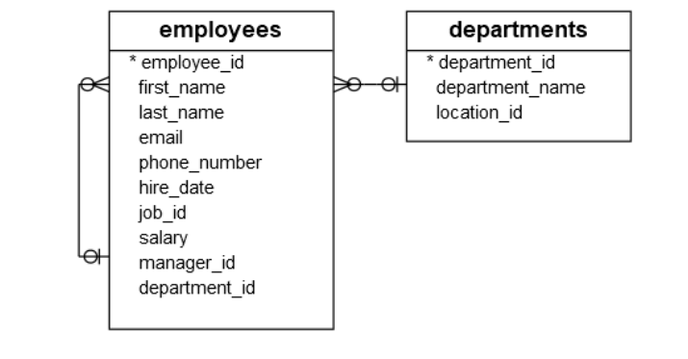

* Using the above set Derive the salary_rank

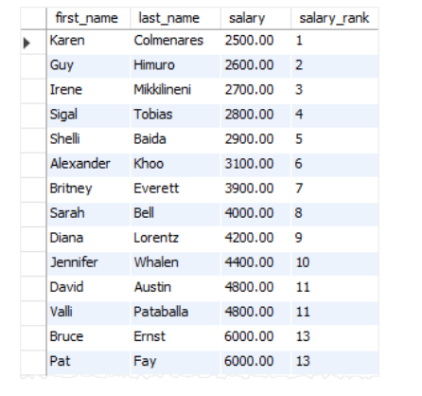

* Using the Employees and Department table find the employees who have the second highest salary in their departments